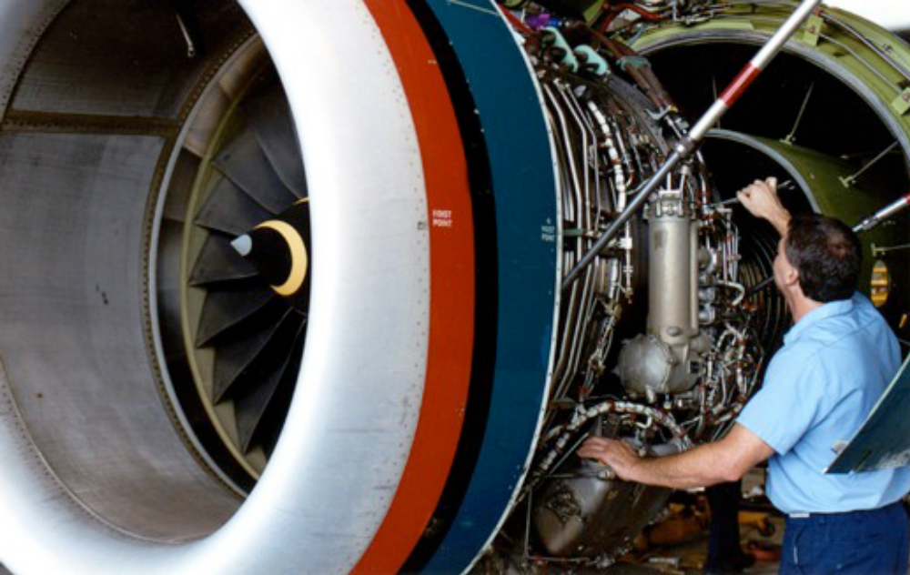

Maintenance System in iPhone

Team

• Taha Amdouni
• Sonila Dobi
• Benedikt Engeser
• Steffen Strobel
• Marcel Stuht
• Benjamin Ullrich

RAD module

1. Introduction

SHORT DESCRIPTION OF THE APPLICATION AND PURPOSE OF THE DOCUMMENTATION

Description 1.1 Purpose of the system
The application is a demo for an Aircraft Maintenance Tool wich serve for communication, controlling, assistance and repairment in distance. This is a software of large dimension and integrates different components. The way it works is similar to the work the Linne Maintainers (LM) and Experts do in the Airports around the world. Basically it does the work of routine after flight inspection, planning for repairment, doing the actual repairment through given instructions, maintenance and job planning. All this is done electronically with the help of this tool which is being developed. Through video streaming the Expert does not have to leave his palace but can do it in distance through the use os wireless devices such as an iPhone. The LM can record everything and save it for later analisys. And the LM can also be instructed from the Expert by using just a phone.

- The software is user friendly with basic and enough functions. It has a step by step self explaining user interface. It solves the daily tasks related to the maintenance in the airport, and now the distance maintenance is made even easier.

- The information is saved in different data storage servers and they are all connected together at the same time to offer all the services. There is one server which will save the aircrafts scheleton, another one wich will save the attachments and another one which will do the streaming of the voice. All these are connectd together with some urls and the identification of the users can be done with a simple web page if not in the aircraft scheleton server.

- The workaload data is changeable depending on how many problems occur per day. But considering the maintenance outside the working place, this adds the works per day. The system should make the work easier for the users since they can access everything by clicking a “button”, therefore this software allows increasing the work and easening the job.

- The input of the program is aircraft models and parts with attachments such as picture, video, and notes made from the LMs and Experts.

- The output is made of different type of media such as voice, video, picture, text and is accessible at any time.

Purpose of Documentation

The purpose of this documentation is to give information for all the developing stages of the software and present the work for a successful realization of it. Here are explained the technical steps needed to build the system. This description might be used for future development in case similar products are going to be developed.

A detailed documentation makes it easier identifying parts that can be reused. This is the main reason for this documentation. Even though we might not want to admit it, it could be that at some point this software might exibit some anomality not foreseen from us. Consulting this documentation might help us solve the problem. This justifies documenting from the beginning of the development until delivery as a maintenance tool for future reference.

Contract

We don’t have it.

INDEX

PRODUCT AND PROCESS………………………………………………………………….7
- Chapter 1 . Product and Process ………………………………………………………...8
  - Software Scope…………………………………………………………………….8
    - Purpose and Context………………………………………………………….8
    - Objectives……………………………………………………………………...8
    - Functioning and Performance…………………………………………………8
    - Dekompositon of Main Funtionalities …………………………......................9
  - Type of software Team.………………………………………………....................10
  - Model of choosen process …………………………………………..……………10
  - Work Flow……………………………………………………………10
  - Schedule Graphic……………………………………………………………………10
SRS…………………………………………………………………………………………...21
- Chapter 2. Software Requirement Specifications…………………………………….22
  - Actual System……………………………………………………………………..20
  - Users and Clients…………………………………………………………….22
    - Category of Users and Clients ……………………………………22
    - Characteristics of Users and Clients …………………………………22
  - Similar Systems……………………………………………………...................22
  - Proposed System………………………………………………………………….23
    - General Overview……………………………………………………...23
    - Techniques used for gathering Requirements.……………………………23
    - Assumptions and Dependencies…………………………………………….23
    - Restrictions………………………………………………………...23
    - Functional Requirements………………………………………………...24
    - Non-Functional Requirements…………………………………………….25
      - Usability ………………………………………………….26
      - Reliability………………………………………………………..26
      - Safety ………………………………………………………………26
      - Security …………………………………………………………………27
      - Performance…………………………………………………….27
      - Maintenance and Update …………………………………...27
  - Use-Case Diagrams……………………………………………………...................29
ANALISYS AND RISKS MANAGEMENT …………………………………………….34
- Chapter 3 . Analiza dhe Menaxhimi i Rreziqeve(Plani RMMM)……………………...35
  - Rreziqe te pergjithshme dhe produkt specifice……………………………………..35
  - Analzia dhe menaxhimi I rreziqeve (tabela)………………………………………..38
  - Plani RMMM……………………………………………………………………….38
MODELING………………………………………………………………………………….44
- Chapter 4 . Modeling……………………………………………………………………45
  - Architectural Modeling…………………………………………………………….45
    - SCD Diagram……………………………………………………………….46
    - SFD Diagram……………………………………………………………….48
  - Data Storage Modeling……………………………………………………………49
    - Schema for Sta Storage ………..50
    - Schema for web dav ……………52
    - Documentation……………………………………………………………….52
  - Class Model…………………………………………………………………..54
    - CRC Model…………………………………………………………………54
    - Class Diagram…………………………………………………………57
  - Graphical Interface Model………………………………………………………60
    - Desktop bla bla………………………………………………………………60
    - Web bla……………………………………………………………………..65
CODE………………………………………………………………………………………70
- Chapter 5 . Code Implementation ……………………………………………………...71
  - WebDav Connector ………………………………………………………...71

HTTP Connector ………………………………………………………………….76
  - VOIP
  - Graphical Interface
TESTING…………………………………………………………………………………..94

- Chapter 6 . Software Testing Verification Validation ………………………………95
  - Testing Techniques………………………………………………………………...95
  - Test Cases……………………………………………………………………...95
  - Document Testing……………………………………………………………...95
  - Conclusions………………………………………………………………………..96

PRODUCT
AND
PROCESS
Chapter 1. PRODUCT AND PROCESS

1.1. SOFTWARE SCOPE 1.2 Scope of the system

1.1.1. Purpose and Contexst

This project aims to build a software which makes the maintenance work as electronically and possible. This software will be used from the Line Maintainers and Experts positioned in different places of the world. The user interface should be friendly and fast to work with since the workaload is regarded to be intense. The software itself offers the possibility to access the different types of aircrafts, their parts and add different kinds of attachments for each of these parts. It also allows voice conference between the LMs and the Experts and generally speaking; interaction between the users. Technically speaking in general terms, it has different connectors which can load the elemts of the aircrafts and connect to the attachments related to these parts which on the other hand are also connected to sessions.

1.1.2. Objectives 1.3 Objectives and success criteria of the project

Input Data
- The Software in the beginning has a complete list aircrafts and their parts, a a list of sessions and a list of users and attachments connected to the sessions. The list of users can be independent of the session.
- For each aircraft elements there is given the ID, the name and the description. Each node might have other child nodes. For example the node of a type of aircraft might have child nodes which are parts of the aircraft such as wings, motors etc.
- Registers the list of the users in general, and the users who want to participate in a certain session.
- Registers the sessions, and their types.

Output Data
  - After all the data is registered in the system, they are shown in the application as a list from which you select each of them and edit them too.
  - Gives the opened and closed sessions list.

1.1.3. Function and Performance

The flow of the input information until its final computation goes through from storage to displaying it. The first stage is to design and model the data. This shows high risk because all the other process will be depend on this. The software needs a precise and known structure of the data so that it can be used correctly from the programming language used.

Aspects connected to performance:

Fast generation of output data, filtring and structuring it as the user demands it.

Fast connection to the data storage servers for updating the data.
1.1.4. Decomposition in main functions:

Below are shown the main functionalities of the system:

- Register the users by categories.
- Store the aircraft types and their parts.
- Strore the attchments related to the aircraft types and parts.
- Register the sessions and their types.
- Register the users to the sessions.
- Enable Voice conference.
- Enable Video Streaming for distance help maintenance.
- Show status of sessions.

1.2. Type of the Software Team

The software team is composed from a Supervisor, a Coach and the programming members. The Supervisor’s role was to identify possible problems during the process and provide with part of the implementation of the system, mostly the server side development. The Coach was side by side with the rest of the team dealing with the administrative aspect such as setting checking the status of the project, pondering the different proposed solutions, setting milestones, etc. The other members had different tasks almost each of them. Steffan had the task related to VOIP, Marcel the Graphical user interface, Benjamin the WebDAV connector implementation, Ben the HTTP connector implementation and Sonila with Taha the Software Engineering Modeling and Documentation. All the team members had to collaborate at some point and integrate all the code. The work has been divided into smaller tasks and the members have worked in parallel and then after each milestones they have discussed the status of the project and continued with the other subtask. This was a very democratized team because the discussions were horizontal in hierarchy and the coach was only making sure everything worked, withought interfering drastically in the decisions made from the team members. The controlling schema was a decentralized one (CD).

1.3. Choosen Process Model

To deliver the software with success in end, there was a need to choose a process model. The choosen model is the XP (Extreme Programming). A general schema of this model is shown in Figure.

This model being an evolving one, makes the work eaier when wanting to make changes even during the different stages of development and documentation. The changes are evident in the design of the data storage, interfaces and all the components of the system in general. The client was close to the developers and therefore the changes were made right away. This is why this was a XP team. The whole system had a lot of new technologies to implement for the team members and required fast adapting to them.

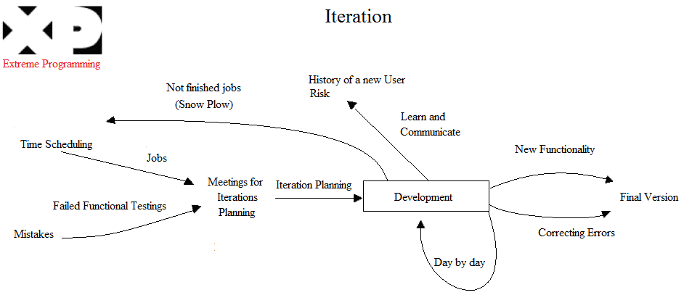
Figure. Showing the Extreme Programming process model.

1.4. Work Flow

This is the work flow which shows the development process from the beginning till the end. This flow has many iterations adn changes during all the stages. It also has some turn back points where there were obstacles and things not working. In the end all the tasks were integrate together. Of course during all the stages there has been continuous testing of the components. The diagram is shown in Figure.

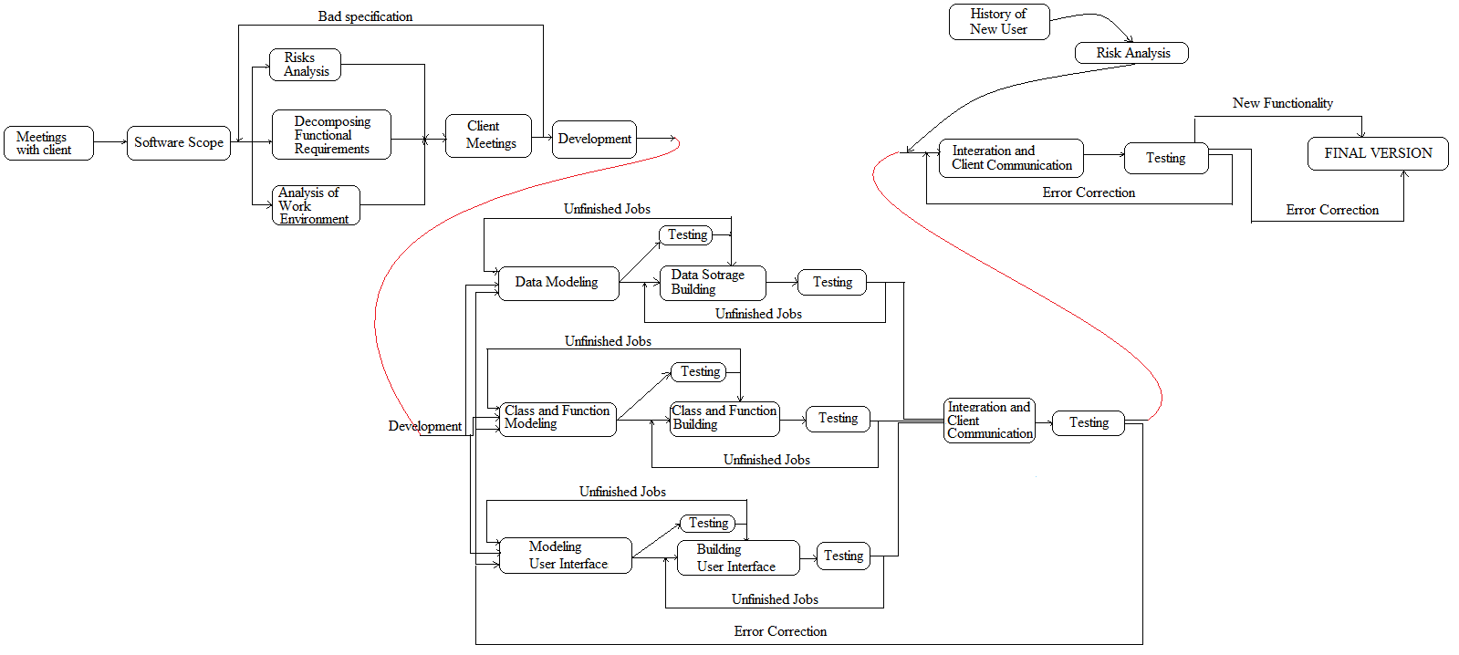

Figure.
1.5 SCHEDULE GRAPHIC (MAKROSKOPIC SCHEDULE).

Basically this is the time we have worked, the scheduled tasks, the milestones and who did what function implementation or what other tasks.

Below is an empty template.

Skedulimi i Punëve në Software: | Java 1 | Java 2 | Java 3 | Java 4 | Java 5 | Java 6 | Java 7 | Java 8 | Java 9 | Java  10-15
"Name i Programit" | 15-Nov | 22-Nov | 29-Nov | 6-Dec | 13-Dec | 20-Dec | 27-Dec | 3-Jan | 10-Jan | 17Jan-21Feb
1.3.9 Printimi |  |  |  |  |  |  |  |  |  | \\\\\\\\\
Printimi i Faturave |  |  |  |  |  |  |  |  |  | \\\\\\\\\
Printimi i Kontratave te Abonenteve |  |  |  |  |  |  |  |  |  | \\\\\\\\\
Printimi I Kartave te Abonenteve |  |  |  |  |  |  |  |  |  | \\\\\\\\\
Printimi I Qerave |  |  |  |  |  |  |  |  |  | \\\\\\\\\
Printim Raportesh |  |  |  |  |  |  |  |  |  | \\\\\\\\\
1.3.10 Raporte Statistikore |  |  |  |  |  |  |  |  |  | \\\\\\\\\
Periudha me e mire e shitjeve |  |  |  |  |  |  |  |  |  | \\\\\\\\\
Produtet me te shitura |  |  |  |  |  |  |  |  |  | \\\\\\\\\
Personeli me I mire |  |  |  |  |  |  |  |  |  | \\\\\\\\\
Etj. |  |  |  |  |  |  |  |  |  | \\\\\\\\\
1.4 Funksionet ne Aplikacionin WEB (Dizenjim) |  |  |  |  | €€ | €€ | €€ | €€ | €€ | \\\\\\\\\
1.4.1 Porosi online |  |  |  |  |  |  |  |  |  | \\\\\\\\\
Autentifikimi ne sistem |  |  |  |  |  |  |  |  |  | \\\\\\\\\
Krijimi I nje porosie te re |  |  |  |  |  |  |  |  |  | \\\\\\\\\
Anullimi I nje porosie |  |  |  |  |  |  |  |  |  | \\\\\\\\\
Kontrolli I nje porosie (behet apo jo porosia) |  |  |  |  |  |  |  |  |  | \\\\\\\\\
Ruajtja e porosise |  |  |  |  |  |  |  |  |  | \\\\\\\\\
Dergimi I Porosise |  |  |  |  |  |  |  |  |  | \\\\\\\\\
Modifikimi I porosise |  |  |  |  |  |  |  |  |  | \\\\\\\\\\
1.4.3 Oferta speciale ne WEB |  |  |  |  |  |  |  |  |  | \\\\\\\\\\
Shfaqja e ofertave ne faqe |  |  |  |  |  |  |  |  |  | \\\\\\\\\\
Dergimi I ofertave tek te gjithe abonentet me email |  |  |  |  |  |  |  |  |  | \\\\\\\\\\
1.4.4 Oferta per abonente te vecante |  |  |  |  |  |  |  |  |  | \\\\\\\\\\
Vleresimi I historikut te abonenteve |  |  |  |  |  |  |  |  |  | \\\\\\\\\\
Vleresimi I Ofertes per abonentet |  |  |  |  |  |  |  |  |  | \\\\\\\\\\
Dergimi automatik me email I ofertes |  |  |  |  |  |  |  |  |  | \\\\\\\\\\
Shfaqja e ofertes ne profilin e abonentit |  |  |  |  |  |  |  |  |  | \\\\\\\\\\
1.4.5 Kerkim artikujsh me fjale kyqe |  |  |  |  |  |  |  |  |  | \\\\\\\\\\
Kerkimi me fjale kyce |  |  |  |  |  |  |  |  |  | \\\\\\\\\\
Shfaqja e alternativave te ngjashme |  |  |  |  |  |  |  |  |  | \\\\\\\\\\
1.4.6 Komentet |  |  |  |  |  |  |  |  |  | \\\\\\\\\\
Lenia e komenteve per artikuj te vecante |  |  |  |  |  |  |  |  |  | \\\\\\\\\\
Leximi I komenteve |  |  |  |  |  |  |  |  |  | \\\\\\\\\\
Rate produkte |  |  |  |  |  |  |  |  |  | \\\\\\\\\\
1.5 Komunikimi ndermejt dy aplikacioneve |  |  |  |  |  |  |  |  |  | \\\\\\\\\\
1.5.1 Kalimi I infO baze nga Desktop Ne WEB |  |  |  |  |  |  |  |  |  | \\\\\\\\\\
1.5.2 Dergimi info konfirmimues desk -> web |  |  |  |  |  |  |  |  |  | \\\\\\\\\\

SDD
Chapter 2 SPECIFICATION OF SOFTWARE REQUIREMENTS

2.1. ACTUAL SYSTEM 2. Current system

The actual system is called Armed and is a desktop application. This means it is not mobile and it cannot be accessed from the actual working place at the same time the repairment is actually performed. The data is not put directly into the system during the inspection and this might lead to some missing information durig the after flight procedure. There is not a possibility to take pictures and save it, so only the narrative description is possible. The distance assistance is not possible, and the expert has to travel until the actual place where the problem occurred to fix the problem instead of voice assisting the Line Maintainer. All these delays might be critical in some situations.

2.2. USERS AND CLIENTS

The users are categorized in different categories because they have to do different tasks. Therefore in the next section their catgories and tasks are introduced.

2.3.1. Category of Users and Clients

The Client is EADS which is Europe’s biggest aerospace company with 120000 employes and revenue of €42.8B. It is well known for Airbus aircrafts. The proposed system will help the client to have a better and faster communication and not loose the flux of flights per day. Also the work conditions for the employers will improove. The users of this system are the Line Maintaiers and the Experts. They will make their procedures of after flight inspection, maintenance and repairing with this new system.

2.3.2. Charecteristics of Users and Clients

The employeers who will use this system need to be familiar with iPhone and possibly iPad and also technical knowledge which they most likely already have. They will probably need some basic training in using iPhone and iPad. Then they might need a quick training in how to use the functionalities of the application.

2.4. SIMILAR SYSTEMS 1.4 References

The new system is like the old one as a base comparision. The main difference is that this is mobile and the other one was not. Recently the company AvFusion have developed an application for iPhone called AvConnect and this app is for Pilot and Aircraft management. It is not exactly the same as the system developed here, but it is an app for iPhone and aircrafts. The link to their website is http://itunes.apple.com/us/app/avconnect-pilot-aircraft-management/id323137573?mt=8.

2.5. PROPOSED SYSTEM 3. Proposed system

The iArmed system has a certain requirement and vision of how it should worl. Below is shown the general overview of the system and some other details.

2.5.1. General Overview 1.6 Overview

The system has different main components. First of all there is a need for the iPhone which will be used from the LineMaintainers mostly but maybe also from some experts. Then is the iPad which will be used only from the experts. The iphones need to connect to the iPad and establish a video conference. In the beginning the problem was whether the iPad could handle many video conferences at the same time. And this has to still be tested, but most likely it will handle only one and there fore the expert has to switch from one video streaming to the other. All the iPhones have to connec to the EMF data storage Server to retrieve the aircraft models and also to the WebDAV wich has stored the attachments related to the elements of the EMF data store Server. There are many risks to take care of such whether the exportation of the models from the iPhone to the WebDAV will be possible in the correct format and reading the data in the other way aswell or not. Then the VOIP should be tested as well because chances are that the connection might not be able to be established.

2.5.2. Techniques for gathering data information

Gathering the basic information of what the final product should look like was easy, because the client was very clear of what he wanted. There was need to discuss technical details with the client regulary after gathering the initial information. The client also introducted the previous system to better understand how it was working and what needed to be changed, added or not used anymore.

2.5.3. Assumptions and Dependencies

The system requires iPhone v.4, iPad, MAC platform for development, WebDAV Connector, HTTP Connector, VOIP Connector, Asterisk format for VOIP conference, AXIS cameras for video streaming.

2.5.4. Restrictions

The team never had an experience working with such a system, so the lack of experience was one the greatest restriction. The testing will be done with only a few devices for practical and budget reasons.

2.5.5. Functional Requirements in RAD 3.2 Functional requirements

Configuring the System

- Registering the Aircrafts and their parts
- Registering the Users and their kategories (Line Maintainers and Experts) together with their login accounts.
- Registering all the devices in the system such as iPhone, iPad, AXIS camera, and testing the connection.
Managing Session
  - Create a new session, edit and delete it.
  - Join/Leave Session
  - Add/Delete user from Session
  - Create and view valid EMF objects and conform to the armed.encore specification.
  - Select Aircraft based on type and call sign
  - Create and view annotations for th EMF elements such as video, picture, text and save them to WebDAV.
  - Automatically reload the EMF model if something changed
  - Browse EMF model and WebDAV attachments
  - Show the users connected to a session

Managing After Flight Inspection Session

Managing Maintenance Session

Managing Repair Session

- Initiate a VoIP conference call after joining a session
- User sets status to ready.
- Expert watches a live video stream from one AXIS camera.
- Users adds new camera to system.
- Expert switches between different video streams.

2.5.6. Non-Functional Requirements in RAD 3.3 non functional requirements

- Usability in RAD 3.3.1 Usability

This system aims to develop an application with userfriendly interfaces which are practical and easy to be used from the end users. The graphical interfaces should have as less steps for a task as possible by asking the user only the necessary input and giving him/her a good feedback. Also the environment of data entry should be familiar to the user, meaning that is should resemble the way he is already working.
- Reliability in RAD 3.3.2 Reliability
      - Should not create any XML files on the server, instead EMF objects should be created.
      - Only authorized users should be able to access the data.
- Performance in RAD 3.3.3 Performance
        - The system should at all time be responsive to user inputs or show a progress indicator.
        - It needs to be usable while working at or inside an aircraft.
        - There should not be noticeable delays when polling the data from EMF store and WebDAV, not big delays in video streaming and VOIP conferences.
        - Also saving all the modifications done in a session should not wait for a long time for a fedback, either good or bad.

- Supportability in RAD 3.3.4 Supportability
This product needs the support from the chair. The requirements are clear but there is need for mainenance from the client side too. It needs also a lot of technical assistence because this is not a typical comercial application. Problems might arise in the future.
- Maintenance and Update
      - The system should have a special iPad interface.
      - The system can make use of existing open source components.

2.5.6. Pseudo-Functional Requirements

2.5.6.1. Implementation in RAD 3.3.5 Implementation
It must run on both the iPhone and the iPad.
2.5.6.2. Interface in RAD 3.3.6 Interface
The ipad is not multitasking and this might create some problems in handling the graphical interface. Also the fast launching of new versions of the sdk of mac, will arise the need for some changes in the graphical interface, but not major ones.
2.5.6.1. Operations
2.5.6.1. Packing in RAD 3.3.7 Packing
2.5.6.1. Legal in RAD 3.3.8 Legal
Legally speaking, this software should not have problems. Perhaps an agreement regarding the importance of using the software from the users is needed. But this is not our concern.

3.4 System models in RAD

2.5. USECASE DIAGRAMS 3.4.2 Use case in RAD

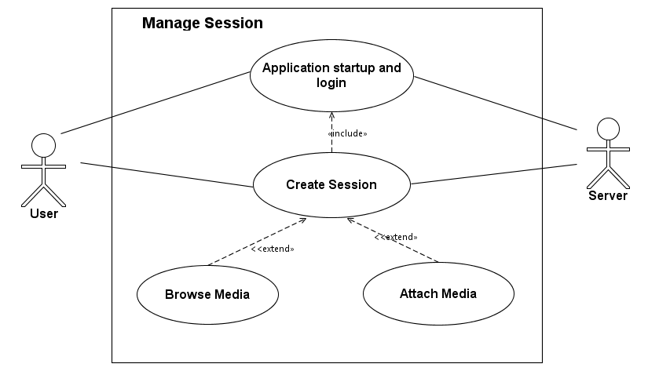

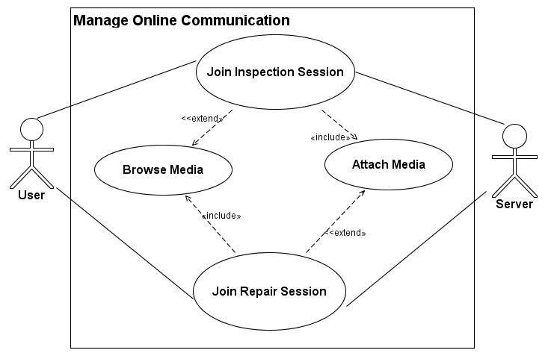

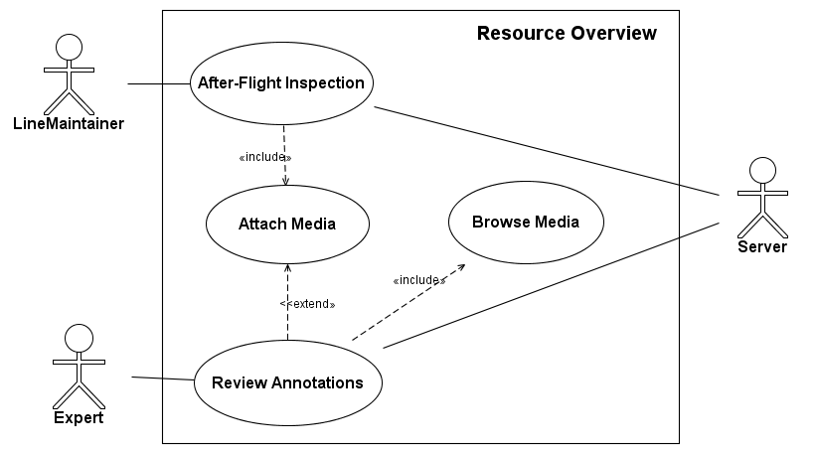

ANALYSIS
AND
RISKS
MANAGEMENT

Chapter 3. ANALISYS AND RISKS MANAGEMENT

3.1. GENERAL RISKS AND PRODUCT SPECIFIC RISKS

1. Risks connected to Product Size (PS):

- The product is decomposed in approximately 17 functions not regarding the subfunctions. For the decomposition the method called Function Points (FP) is used.

- This product is not only a simple application, but an integration of very different components. It requires experience in part which makes the connection between the application on the iPhone, and the rest which incoudes the HTTP, WebDav and VOIP connector. This one of the most critical problem we might have during development.

- The number of the users of this product is very big. This might cause problems in the future if there is a bottle neck in the communication during flux time of the day.

- Considering the size of the system, the best thing to do is to identify components which might be reusef. So far it does not seem there is such component. This shows a big risk that the product might not be delivered on time due to developing from scratch in most of the cases.

2. Risks connected to Bussiness Impact (BI):

- It is believed that this product would make the work at the airport mucht easier for the technicians. This product might be used for many aircraft agencies around the world, since this is a world size problem. Therefore this is a very potential largely usable product in the market.

- The graphical interface should be easy and fast to use. The Linemaintainers and the experts should realize their job with as many as less movements. Therefore there should have been made sure the flux of the work is taken in account and the exact kind of work the technicians do daily.

- It would be nice to have a good looking product. In this way more potential client will be attracted to purcase it in the future.

- As a rought overview of the workaload, it seem the product can be finished on time. But a bad judging of the difficulties of developing this product might put in danger finishing all the functionalities on time, and also the failure of the work of the team members.

- Another risk would be to put on the market a diffective product. A product that cannot realize connection, storing, retrieving data, or errouneous information etc. It might also be that the clients or users do not like it at all. This would be the complete failure.

- The product will be docummented to offer the users a full servise. This should not be difficult, but the documentation should be updated as soon as there is an update in the development.

3. Risks connected to Client Characteritics (CC):

There should not be problems of this type since the client has agreed to collaborate with the developers since the beginning and will be present in each step. The only potential problem which might arise is whether the client will not provide us with the external components on time. There is collaboration in developing this product between the developers and the client.

4. Risks connected to Process Specification (PPS):

- The chosen process Model is Extreme Programming (XP). This model helps to overcome difficulties by working in pairs and solving it as soon as possible. Also the presence of the client is essential. Could be that the clients demands one thing in the beginning and something else in the end. This makes the developers work more difficult, but since the client is present all the time, this problem might be solved easily.

- This process requires that the docummentation should be done during the whole process, to have a look at it at any moment when needed.

5. Risks Connected to Devolopment Environment (DE):

The main problem was adapting to using the MAC devices and platforms. Not all of us were used to them before. And even those who were, were just regular users and not developers. Also the fast evolvment of MAC requires chekcing the SKD and update it if necessary. Sometimes even the code needs to be changed and adapted. But there was support from the chair at the university to make these changes as easy as possible. Hopefully there will not be any major changes before delivering the product.

6. Risks connected to Used Technology (UT):

- This is one of the most challeging tasks, dealing with the new technology. As mentioned before this is a new technology for us. The platform is MAC of Apple, the SDK is for iPhone and iPad, and the programming language is Objective C and also COCOA. All this requires intensive investigation and practice. At some point unsolveable problems might be faced and this is a major risk.

7. Risks connected to Size and Team Experience (STE):

- The team members have previous programming experience, but have never worked together before. Until this project they did not even know each other. There is the risk that there might not be good communication and collaboration.
- Not all of the members have experience in working with the give platform, if none. There is need for time and learing.

- The time at disposal might not be enough to finish. And not to forget the team members are all students and need to be trained before.

3.2. ANALISYS AND RISKS MANAGEMENT

Risks Table

Risks | Category | Probability | Impact | RMMM
No integration of all the components | UT | 90% | 2 | ID_1
Step by step docummentation might be overlooked | PPS | 90% | 1 | ID_2
Missing experience for the used tools | DE | 80% | 3 | ID_3
Bad evaluetion of the project size | PS | 80% | 1 | ID_4
Client changes the requirements | PS | 60% | 2
Graphical user interface is not enough appealing | BI | 50% | 1
The number of users is greater then predicted | PS | 30% | 3
Less code reuse then predicted | PS | 40% | 2
Team members with no experience | STE | 30% | 2
Missing support from the technology | UT | 30% | 2
Not user friendly graphical interface | BI | 30% | 2
The product might not be fully tested and it might be faulty | BI | 10% | 3
Figure.

In Figure. The table is showing the risks threatening the project. Above the dividing line are listed the risks which are the most important ones to be treated. Each of them has a reference identified by ID_ and following is the rendor number as in the table of RMMM.

3.3. RMMM PLAN

(ID_1) No integration of all the components

Preventing and Alleviating Strategies

This is a problem other developers might have encountered too. The important thig is to make sure each component works bugfree on its own and increase the abstract level as much as possibe to ensure components low coupling.

Monitoring Strategies

To ensure the components communicate with each other, we should make sure there is network and see if there is too much flux or not.

Managerial Strategies

In case the servers which ofer the services such as EMF store data, attachments, and VOIP, fall down, the users should be notified of the problem and there should be some backup syste, and the offline application should still be working and waiting for further updates and uploads.

(ID_2) Step by step docummentation might be overlooked

Preventing and Alleviating Strategies

In the chosen process, it is very important documenting daily. It would be a good idea to include documentation at the end of each functionality. This alleviates the job of the other tea members. Another good idea is for each member to mark the percentage reached at the end of each day of the task he or she has been doing.

Monitoring Strategies

The task schedule and other tempaltes used for docummentation, should be controlled regularily from the coach and the supervisor. This ensures the tasks can be solved on time, or other strategies can be used in case the tasks cannot be finished in the actual manner.

Managerial Strategies

At the moment the deadline has reached and the project has not yet started, or only a functionality has not been finished, or one of the team members has been slower then the others, then precautions should be taken such that for this particular function or member, more time is needed. The tasks should be redestributed among the members, so that one that works faster of better can have a bigger workaload. The client can be conntacted for asking more time.

(ID_3) Missing experience for the used tools

Preventing and Alleviating Strategies

All the tools are new to the team. The best thing to do is to read beforehand the materials and the tutorilas offered fromt he chair and the internet. This will avoid panic in the end.

Monitoring Strategies

Have continuos consulting with internet and especially forums. Take a look at similar projects. See the possibility of reusing ezisting code on internet. One of the team memebers might have more eperience in a certain technology, therefore he or she might control the work of others and propos ideas.

Managerial Strategies

The moment one of the members is in difficulties and canno solve a problem alone, he or she can be helped from the other team members, and the task might be redistributed to the other team members for faster performance.

(ID_4) Bad evaluetion of the project size

Preventing and Alleviating Strategies

Taking in consideration the risk of the produt being too big then predicted, the team is ready to work on the tasks of each others besides their own tasks. This ensures making the most of the possibilities. In case there is not possible to realize all the tasks, then we will seek for other solutions which are known by us to be working, even though not in the most favorite fashion.

Monitoring Strategies

Monitoring will be done step by step during the development since from planning until the reation of the client to the final product. We will discuss with all the team members the faced problems and try to solve them.

Managerial Strategies

The project will be modularized as much as possible and therefore the complexity will be small. In this case, adding another module will be easy, or even modyfying the existing ones. We have taken in consideration that the product might be expanded in the future.

MODELING

Chapter 4 MODELING
4.1. ARCHITECTURAL MODELING

The model is the one named „Architecture with five levels“. The elements are as follow:

1. Presentation

The information which comes from the servers is presented in the client application.

2. User Interface

There are different user interfaces for the Experts and different for the Line Maintainers. The experts have also the interface on the iPad which the LM do not have at all.

3. Business Logic

The users of the system are mainly technician who know what to do. The only thing missing is accustoming to the use of iPhones and iPads. Basically we are dealing with trained users. The bussinesses focus in on making the application work and have good performance. The visual details are secondary.

4. Managing and Control

The communication should be syncronized so all the components of the system should communicate altogether at some point. The EMF models can be updated every some seconds on the client presentation, but we should make sure that all the updates are shown on time to each client. All the users shold be notified at the same time if some change occurs. The video and voice streaming might have some delays, but the users should be notified when the connection is established. The other users should be notified when a new participants enters or leaves the conference room.

5. Data Storage

The storage is done in two different servers. One saves the EMF models and the other the attachments related to these models. The logic is different. In the EMF storage there is a tree model, while in the WebDav server which contains the attachments there is only a link and the link is referencing a model, so there is no specific structure.
3.4.4 Dynamic model in RAD

4.1.1. SCD Diagram

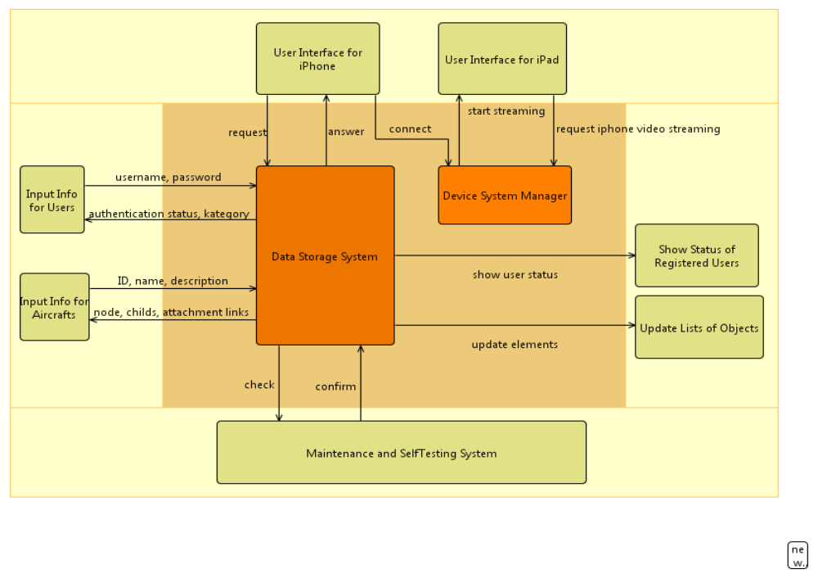
Figure.

The Figure. Shows the SCD diagram which shows the general overview of the all the tasks of the system and the way the user interacts with the system.

The system is composed of five main parts which are:

- Input Data: The iput information is the user authenitcation and the EMF elements information. This part commuicates with the Data storage system through ID, name, description, username and passord. According to this input, the system generates the proper output. This output is then transferred to the graphical system.

- Communication Interfaces: There are two types of interfaces, the iPhone and the iPad. The information can be shown on both interfaces. The difference is that on iPad the user can see the video streaming which is sent from the iPhones.

- Output Data: This part generates the output information acording the input and the user requests. It can be the status of the user connected to a session, the infromation of a specific element of the EMF model, the infromation of a specific attachent etc.

- Maintenance and SelfTesting System: In this modul continuous requests and security controls are made. It makes sure the connection is established and there is no erroneous data. Also no interference from third parties should be allowed.

- The main part of the diagram makes the information processing together with the device management system. This is the most important part of the system because this realizes the logic of the business.
    - SFD Diagram
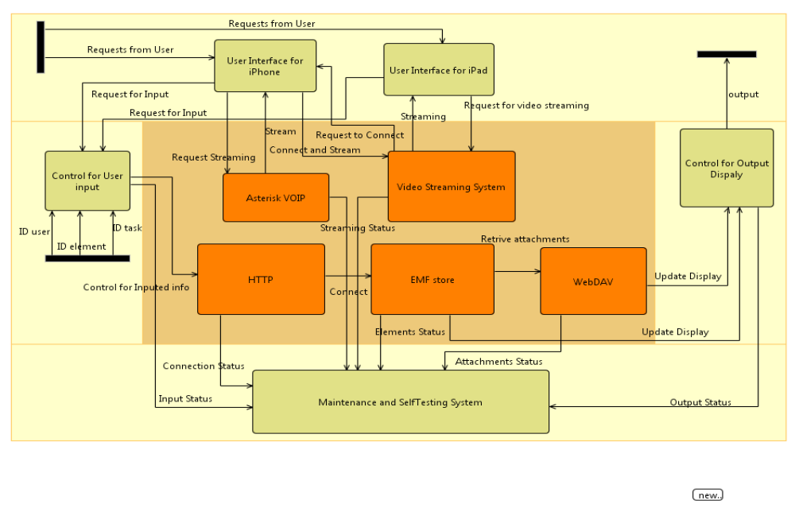
Figure.
In Figure, is shown the SFD diagram which shows the job flow in the system. As a beginning the User logs in the system with a username and a password and this will be checked in the EMF store. The connection to the EMF store is done throught the HTTP proxy server. After being identified, the user can make other requests such as browsing through the aircrafts types, adding attachments, joining a session, joining a voice conference, sending video streaming etc. Every modification is sent to the output and displayed either on the iPhones or iPads. All the time the information is checked in the testing subsystem, whether the connection is maintained, the format of the objects is the right one etc.

4.2. DATA STORAGE MODELING
4.2.1. EMF SCHEMA

This is the old schema of armed. The new schema will be something like this but probably less complicated.

4.2.3. Documentation

(this should be about how the whome application would work, but i just put the scenarios as they were. Some technical data should added as to where happens all in the scenarious in the real schemas above)

3.4.1 Scenarious in RAD

Analyse Arisings Scenario
The maintainer inspects the aircraft and is looking for system damages.
Therefore he has to do an analysis of the arisings of the aircrafts cpus.
The arisings have already been downloaded from the aircraft and are available for downloading via http..
The maintainer opens the iArisings App and imports the proper file via http from a webserver. This file is
automatically forwarded to the Arisings Analysis Server who is examining the data and sends the result back to
the iArisings app. The result is sent in XML format.
The iArisings app presents the result just like the existing desktop application.
Structural Damage inspection session - Maintainer
The Line Maintainer starts the iArmed app.
He gets a list of planned repair sessions that he is supposed to participate.
He chooses the "Wing Damage Inspection" Session that is supposed to start in 30 Minutes.
The Line Maintainer gets a list of participants. He can also see a list of attachments like pictures, repair
instructions or videos.
The Line Maintainer opens the document "Wing Damage Repair Preparations.doc" and follows the contained
instructions.
At the time the session starts the other participants join the session.
When the Maintainer is ready to begin the repair, he sets his status to ready.
The application automatically connects to an asterisk conference call with all participants via VoIP.
The maintainer is instructed to take a picture of the damage and share it with the other participants. He takes
his iPhone and uses the built in camera to take a picture. After taking the picture the maintainer gets a preview
so he is able to check if the picture is showing the damage properly. The picture isn't sharp enough so he
chooses to take a new picture. The new picture is perfect so he decides to use it.
As the damage is hard to see the maintainer wants to annotate the image to point out to the other participants
where the damage is located. He chooses the annotation mode and draws a circle around the damage. Then
he adds a text note to the picture. After that the image is ready for sharing so the maintainer selects "Share
Image".
The software proposes a name for the picture "20100421-1603 - Wing Damage Inspection - Picture 1". The
Maintainer could change the name but decides that he wants to use the proposed one and confirms. The
Image file is sent as attachment and linked to the current session.
Other participants can then find and open the image file in the file attachments list.
The maintainer continues with the examination of the damage and gathers additional information. He wants to
link this information to the image file that he has attached to the session before. He selects the image file and
chooses the "Add voice annotation" functionality.
The iArmed app shows the voice annotation UI and the maintainer starts recording. He is talking with his
bluetooth headset activated and describing the additional information he found. After he has finished he selects
stop and can listen to the audio file again. He decides that the recording quality is good and sends the audio
annotation to the server, which attaches it to the image file.
The maintainer has gathered all necessary information about the damage, so the inspection session is finished.
He selects leave session and closes the iArmed app.
Structural Damage repair session - Expert
A remote maintenance session is scheduled to start in 5 minutes. Due to high traffic the expert is not able to
reach his workplace in time. He decides to leave the autobahn and park his car in order to join the session with
his iArmed app.
He opens the iArmed app on his iPhone and selects the "Structural Damage Repair" session. After joining the
session he sets his status to ready and is automatically joining the asterisk conference call via VoIP.
The maintainer has provided a live video source using an AXIS Video server that can stream video via
MotionJPEG or H264. In order to be able to supervise the repair of the maintainer he chooses to open the
video stream and can watch it on his iPhone.
The expert gives the maintainer instructions via the conference call until the repair is finished. After that he
leaves the session and closes the iArmed app.
After Flight Inspection - Maintainer
After the aircraft has returned from a flight the Line Maintainer has to perform an After Flight Inspection.
He starts the iArmed application and starts a new Session. He enters a session name and selects the Voice
annotation feature and gets an overview over the model of the aircraft.
The maintainer starts his inspection and finds a damage at the left wing. He puts on his BT headset, takes his
iPhone and selects the "Wing, Left" Element from the aircraft model. Then he starts recording and gives a short
description of the damage. Then he stops the recording. The maintainer decides that he has to further
investigate the damage, therefore he has to enter a maintentance manhole. As his movement is very restricted
and the maintainer won't be able to operate the iPhone during the inspection in the manhole, he starts the
recording on spec. He finds a damage at the fuel pipeline and describes it. After he has left the manhole the
Line Maintainer saves the recording to the "Wing, Left - Fuel Pipeline" modelelement.
The Line Maintainer finishes the inspection without any further findings so he closes the session and closes the
app.

3.4.3 Object model in RAD
4.3. CLASS MODELING

4.3.1. CRC Model

Maybe there is no point of doing it unless the classes are specified completely. But once the class diagram is finished its easy to finish this part too.

4.3.2. Class Diagram

There should be a final version.

Im putting what I havo so far
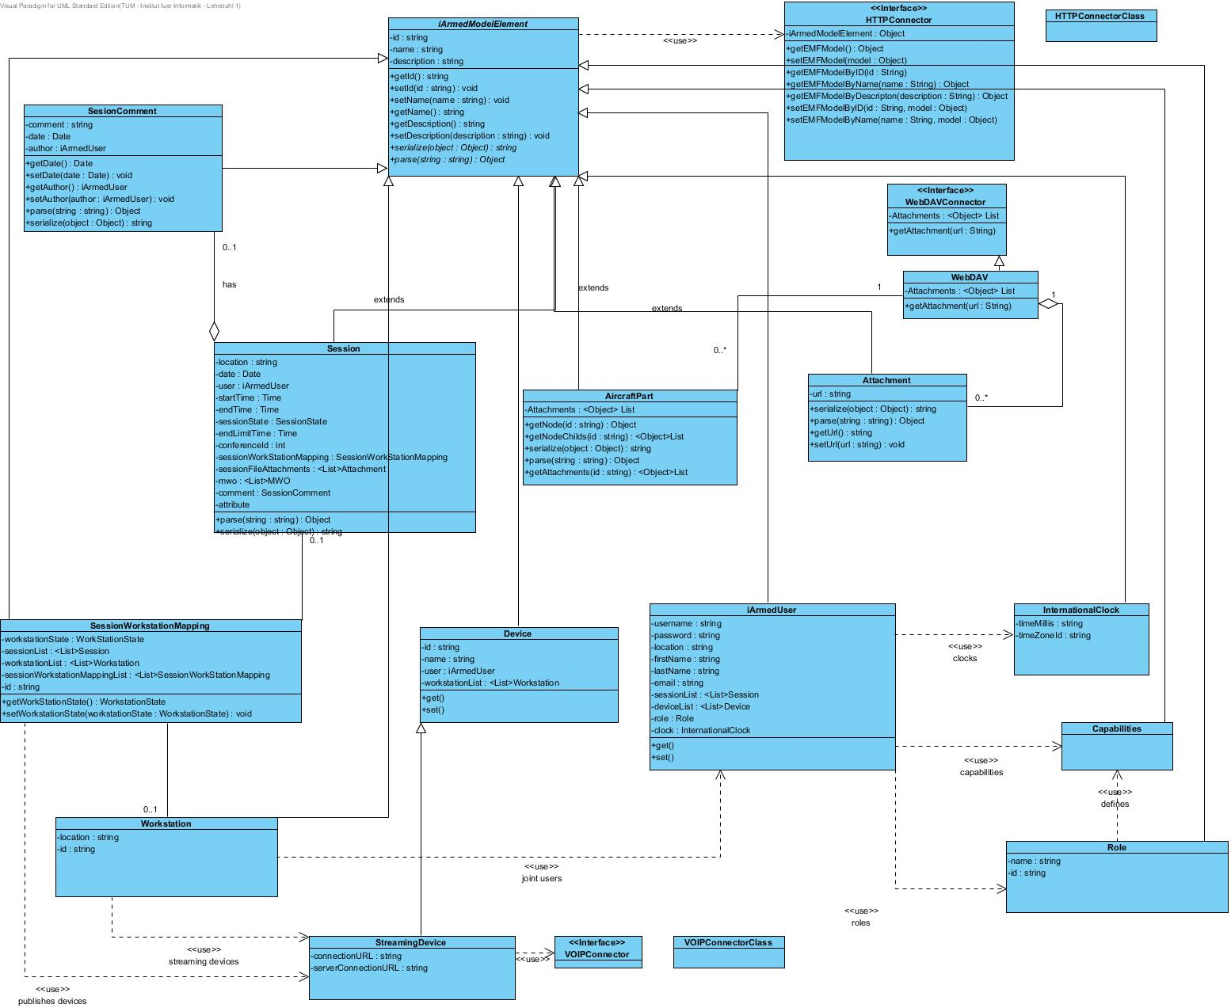

3.4.5 User Interface – navigational paths and screen mock-ups
4.4. GRAPHICAL INTERFACE MODELING

The screen shots marcel did.
CODE

Chapter 5. CODE IMPLEMENTATION

Classes with their source code.

TESTING

Chapter 6. SOFTWARE TESTING VERIFICATION AND VALIDATION

During the testing of the product, we have concentrated in realizing the following main points:

  - The final product is the one the client wants
  - The final product fullfills all the functions the client requested
  - The final product is reliable and safe
  - The final product functions as a whole in a correct way

6.1. TESTING TECHNIQUES

For testing the software we have used Black-Box and White-Box techniques.

6.2. TEST CASES

- Assuring all the possible cases inside each module are tested atleast once.
- Proof of all the logical predicates either when the result is TRUE or FALSE.
- Executing all the cycles with the estreme values aswell as the ones within the extremities and checking the results.
- We have used the inner structures of the data storage to assure their validity.

Mainly the system has been tested from the graphical interface. During implementation of the modules, we have also tested them by setting input values within the allowed limits and also outside the limits to check the behaviour. WE have also checked the performance of each module in anycase and have changed parts of the code where errors have been identified. Besides this kind of testing, we have done a general testing to check how well the modules are integrated together. We have also tested the system from another aspect, that in case of malfunctioning of hardware or security threads. For the main functions we have followed all the path from the beginning till the end. We have fully ckecked the main scenarios. The followed technique is that of debugging.

6.3. DOCUMENTATION TESTING

This is a very important test for debugging. We will add as many information as possible during the whole development process and afterwards too.

6.4. CONCLUSSION

….

